Writing about a thing, an object or an animal
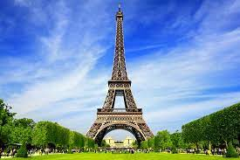
‘WHICH’
Paris is the capital of France.
What else do you know about Paris?
- Size: It is huge.
- Famous for: It’s famous for its fashion.
- Location: It is in the north of France.
- How far from Calais: It’s about 150 miles from Calais.
Now give 2 facts about Paris in the same sentence.
Paris, ……………………………………………………………., is the capital of France.
Paris, which is huge, is the capital of France.
Paris, which is famous for its fashion, is the capital of France.
Paris, which is located in the north, is the capital of France.
Paris, which is about 150 miles from Calais, is the capital of France.
The main piece of information is that it’s the capital of France. You can also add some information in the middle to make it more interesting.
To add extra information to describe a thing, an object or a city, use which
You need to use commas before and after the extra phrase.
Cardiff is the capital of Wales.
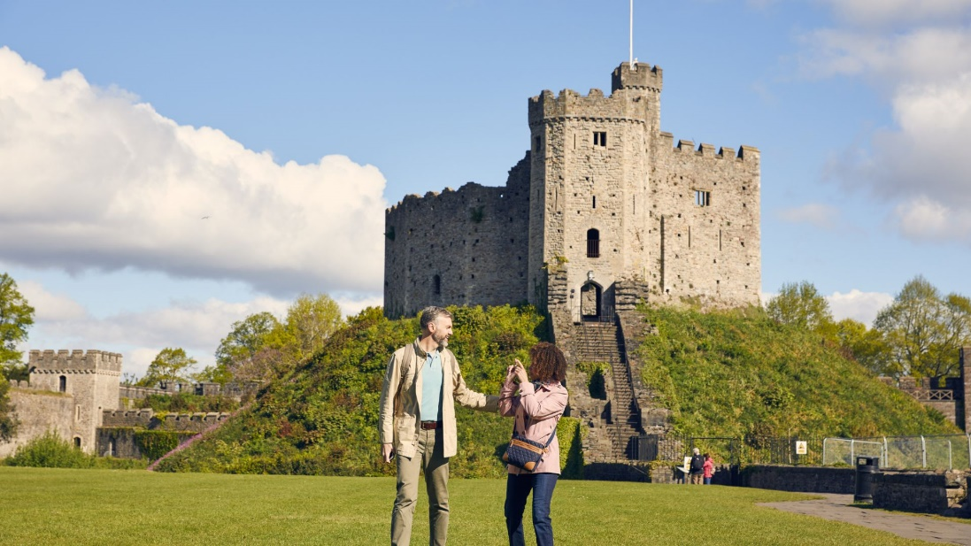
What else do you know about Cardiff?
- Location: It ………………………………………………………………………………
- How far from London:
It ………………………………………………………………………………………
- How many inhabitants are there?
It has .........................................................................................
- What do you find there?
It has ……………………………………………………………………..……………..
…………………………………………………………………………………………………
- …………………………………………………………………………………………………………………………………………………………………………………………………...
Now add information about Cardiff in the sentence.
Cardiff, which …………………………………………………………………………..., is the capital of Wales.
Cardiff, which ………………………………………………………………………………………………, is the capital of Wales.
Cardiff, ……………………………………………………………………………………………………………
………………………………………………………………………………………………………………………

ANOTHER CITY: ______________________________________

Now write your main sentence about a city that you know.
…………………………………………………………………………………………………………………..

Now write 3 facts or pieces of information about that city.
- It ……………………………………………………………………………………………………………
- It ……………………………………………………………………………………………………………
- It ………………………………………………………………………………………………………….

Finally, write 3 sentences which include the main fact and 1 extra piece of information (in the middle of the sentence), using commas.

- …………………………………………………………………………………………………………………………………………………………………………………………………………………………

- …………………………………………………………………………………………………………………………………………………………………………………………………………………………

- ………………………………………………………………………………………………………………………………………………………………………………………………………………………..


Writing about a person ‘who’

Martin is my best friend.
Write 4 facts about him (job, hair, enjoys, lives,….)

- He has four children.
- He……………………………………………………………………….………..
- ……………………………………………………………………….…………….
- …………………………………………………………………………………….
- ……………………………………………………………………………………..

Now write 2 facts about him in the same sentence.
Eg, Martin, who has four children, is my best friend.
- ……………………………………………….……………………………………………
- ……………………………………………………………..………………………………
- ……………………………………………………………….…………………………….
- …………………………………………………………………..………………………….

Writing about what happens / happened in a place.
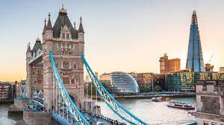
‘where’
London is a beautiful city.

I met my best friend there.
I found a job as a taxi driver there.
I visited Big Ben there.
I had a lot of close friends there.

- London, where I met my best friend, is a beautiful city.
- London, where I found a job as a taxi driver, is a beautiful city.
- London,…………………………………………………………………………………………………………………………………………………………...
- …………………………………………………………………………………………………………………………………………………………………………
(‘there’ disappears in the long sentence!!!)

Write about a city you know: _____________________
What is your main sentence?
_________________________________________________
Write 4 things that happened there?
- …………………………………………………………………………………..
- …………………………………………………………………………………..
- …………………………………………………………………………………..
- …………………………………………………………………………………..
Now write 4 sentences including two pieces of information about that city (the main one + another one in the middle)
- …………………………………………………………………………………………………………………………………………………………………………
- ………………………………………………………………………………………………………………………………………………………………………..
- ………………………………………………………………………………………………………………………………………………………………………….
- ……………………………………………………………………………………………………………………………………………………………………………

(Try and use which, who & where in your writing to create complex sentences. Look at sentences you have written and add extra information)
You can also use the link below to practise online:
https://agendaweb.org/grammar/relative_pronouns_clauses-exercises.html

